**Global Happiness Report**

**Sharon Thapa**

**April 2025**

Tableau: <https://public.tableau.com/authoring/GlobalHappinessReport_17448597887260/GlobalHappinessProject#1>

Github: <https://github.com/sharonthapa>

**Introduction**

The dataset is sourced from Kaggle and provides a detailed record of the countries/regions ranking in overall happiness. The World Happiness Report is a landmark survey of the state of global happiness. The World Happiness Report ranks countries from around the world with columns following the happiness score estimate the extent to which each of six factors – economic production, social support, life expectancy, freedom, absence of corruption, and generosity – contribute to making life evaluations higher in each country by their happiness levels, It provides us with comprehensive information about and contributing factors to happiness.

The analysis will cover five years (2015 to 2019) of data to facilitate research and analysis, enabling us to explore patterns, understand underlying causes, and will provide us with insight on the correlations.

**Project Objective:**

* Understand how happiness score has evolved over time.
* Identify major factors determining happiness.
* Explore regional differences in happiness.
* Utilize geospatial analysis to determine happiness correlations.
* Present findings

**Data Source:**

The World Happiness Report is a landmark survey of the state of global happiness. he reports review the state of happiness in the world today and show how the new science of happiness explains personal and national variations in happiness.

<https://www.kaggle.com/datasets/unsdsn/world-happiness/data>

**Data Categories:**

**Categorical Features**: Country and Region

**Numerical features**: Happiness Rank, Happiness Score, GDP per Capita, Family, Health (Life expectancy), Freedom, Trust, Generosity and Distopia Residual

**Reason for Dataset choice:**

This report provides a comprehensive reporting on global happiness metrics. Data is available at a country and regional level, includes different socio-economic factors such as GDP per capita and health (life expectancy) etc. It spans over 5 years. The dataset originates from a widely used global study offering reliability.

**Data Profile:**

**Data Cleaning:**

Ensure titles were the same

- Removed standard error(2015), Distopia residual ( a hypothetical country), family (as it was in

- added the average for missing values in family for each country for year 2018 and 2019 due to the fluctuation from 2015 to 2017

- Removed Northern Cyprus as it is not a country

-Removed Social support entirely as it was not available for the 2015 to 2017.

**Consider limitations and ethics**

**-**Data collection biases: This dataset relies heavily on self reported survey and happiness is very subjective as it can vary vastly depending on many factors, eg. Cultural

-We don’t have access to how broad the survey was, was it collected from urban areas, rural areas

-GDP per capita is not a complete measure of economic wellbeing. Income inequality is not considered as there can be high economic disparity which can affect the data.

-The data is a country level data but ensuring data protection on individual level is still necessary.

**Define questions to explore:**

**General:**

-Which country has the highest/lowest happiness score?

-How does happiness vary across regions?

-What are the factors to the happiness score?

**Relationship based questions:**

-What is the relationship between GDP per capita and happiness?

-How does life expentancy correlate with happiness?

-Does greater freedom mean more happiness?

-**Time series & Trend Questions:**

- How has happiness changed over the years (2015-2019)?

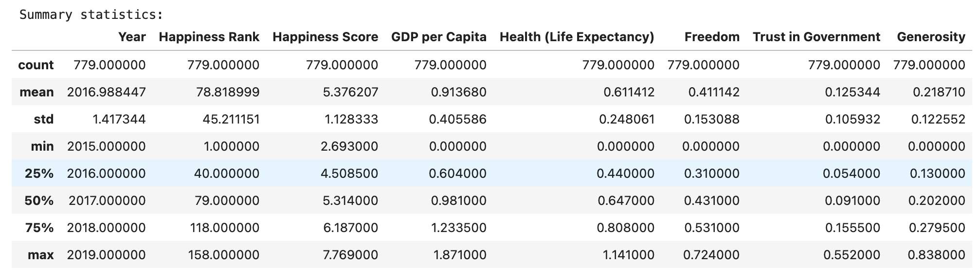

**Correlation Analysis:**

**Correlation Matrix Analysis of Happiness Factors (2015-2019)**

**Key Observations from the Correlation Matrix**

**1. Happiness Score Correlations:**

-Strong positive correlation with GDP per Capita (0.79) → Wealthier countries tend to have higher happiness scores.

-Strong correlation with health (Life Expectancy) (0.74) → Countries with better healthcare tend to be happier.

-Moderate correlation with Freedom (0.55) → More freedom contributes to happier nation.

-Weaker correlation with Trust in Government (0.4) → Less corruption is somewhat associated with happiness.

-Weak negative correlation with Generosity (-0.14) → Generosity does not seem to impact happiness.

2**. GDP per Capita Correlations:**

-Highest correlation with Health (Life expectancy) (0.79) → Wealthier nations invest more in healthcare.

-Moderate correlation with Freedom (0.35) → Richer countries tend to have more freedom of choice.

-Moderate correlation with Trust in Government (0.31) → Richer countries tend to have more Trust in government

- Weak negative correlation with Generosity (-0.013) → Generosity and GDP do not have a correlation.

**3. Health (Life Expectancy) Correlations:**

-Highest correlation with GDP per Capita (0.79) → Wealthier nations invest more in healthcare.

-Moderate correlation with Freedom (0.34) → Healthier populations tend to have more autonomy.

-Weak correlation with Trust in Government (0.25) → Trust in Government does not tend to affect life expectancy.

-Weak correlation with Generosity (0.012) → Generosity does not increase life expectancy.

4**. Freedom Correlations:**

-Moderate correlation with happiness score (0.55) → More freedom leads to higher happiness.

-Moderate correlation with Trust in Government (0.46) → Freer societies tend to have lower corruption.

-Moderate correlation with GDP per capita (0.35) and Health (life expectancy) (0.34) → Freer societies tend to be richer and have higher life expectancy.

-Weaker correlation with Generosity (0.29) → Generosity does not always mean more freedom.

**5. Trust in Government Correlations:**

-Moderate correlation with freedom (0.46) and happiness score (0.40) → People in freer and happier societies tend to equate to lower corruption.

-Moderate correlation with GDP per capita (0.31) and Generosity (0.32) → People with higher generosity and income tend to equate to lower corruption.

-Weak correlation with Health (Life expectancy) (0.25)→ Corruption is a factor in life expectancy but not as strong as others.

6**. Generosity Correlations:**

-Moderate correlation with Trust in government (0.32) → More generous countries may have less corruption.

-Weak correlations with Freedom (0.29) , Happiness score (0.14) and life expectancy (0.012)→ Generosity does not significantly affect happiness, health, or does not equate to freer country.

- Weak negative correlation with GDP per capita (0.013) → More generous countries are not wealthier.

**Conclusion**

The correlation matrix confirms that economic factors (GDP per capita), health expectancy and freedom are the strongest predictors of happiness. On the other hand, generosity and trust in government do not play a big role in happiness.